***SOFTWARE DESIGN DOCUMENT***

**1.0 Introduction**

The sole purpose of the software design document is to give a description of the Meezy Cutz appointment booking system. Topics included are:

* Class diagram
* User interface design
* Method/Operation specification
* Interaction diagrams
* Database design
* Test cases

All in all, this document should leave the reader with a clear understanding of how the use of the online appointment system works.

**1.1 Goals and objectives**

Overall goal of the project is to allow customers to create an online account so that they are able to make an appointment. After a customer books an appointment, they will have the ability to modify or cancel their appointment via the booking system.

**1.2 Statement of scope**

The website offers a convenient way for customers to book appointments through a booking database. The system allows for customers to easily pick a time and date of their desire to book their appointment. The benefits of the database is the ease of use and the reliability for the client rather than directly contacting the barber. This also benefits the barber, so that they automatically receive the appointments via email.  **1.3 Software context**

**User:** The user of this program

The software is placed in a business or product line context. Strategic issues relevant to context are discussed. The intent is for the reader to understand the 'big picture'.

**1.4 Major constraints**

A major constraints that we have faced would include the completion of the database.

**2.0 Class Design**

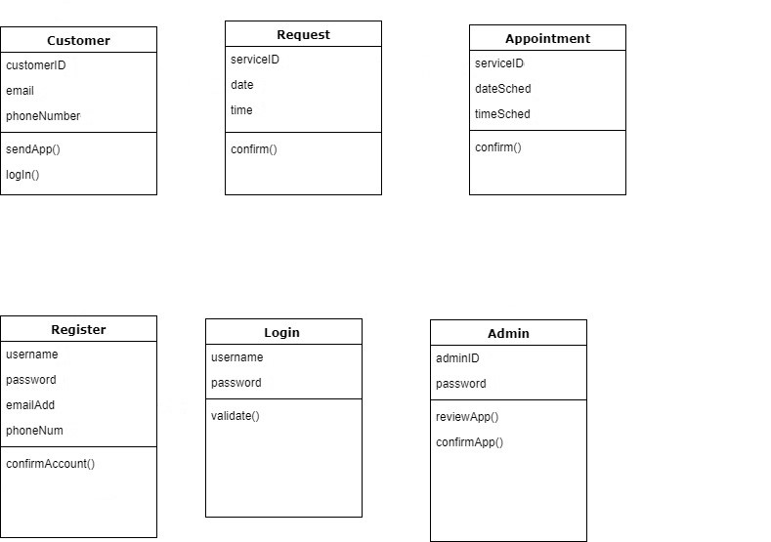

A description of all data structures including internal, global, and temporary data structures.

**3.0 Test Cases**

* What if the appointment is not successfully processed?
* What if the customer is unable to login to their account?
* What if confirmation email does not send to the Admin?
* What if the site is down and appointments are lost?
* What will the admin receive from the database after an appointment?
* What if the database shuts down and clients are unable to book?

**4.0 User interface design**

A description of the user interface design of the software is presented.

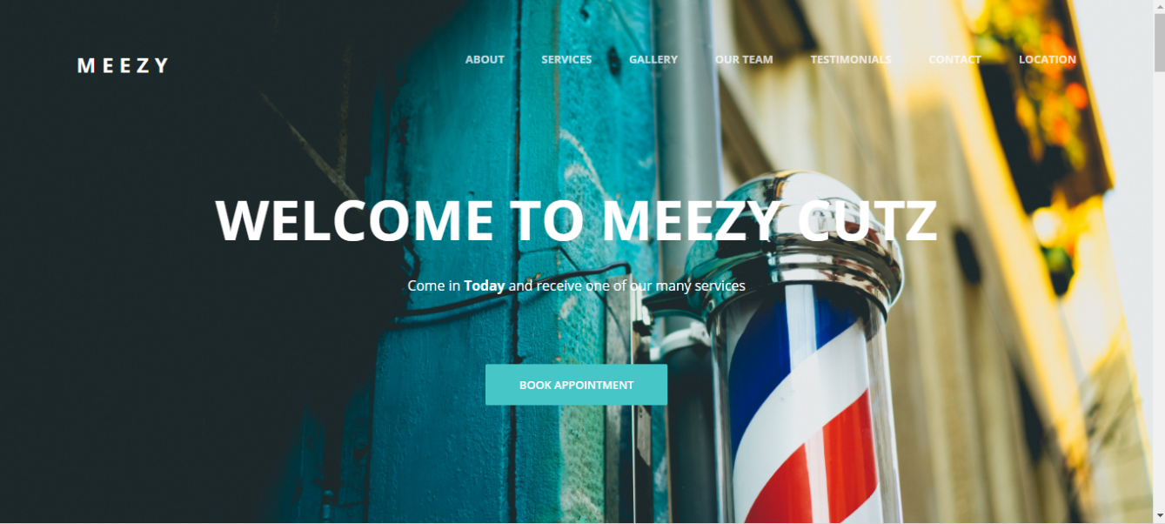

**4.1.1 Screen images**

